Q01
Step01: Analyze q1 with ghidra
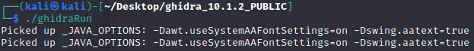
Steop02: According to the report, the program “rot”our input
Step03: The password is “I Love Cyber Security!”But the output looks like this
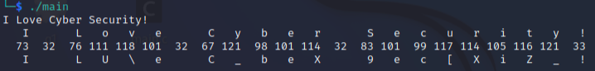

Q02
Step01: According to ghidre, the main function is to find the IP address of a host called “csf.is.a.great.course.yay”
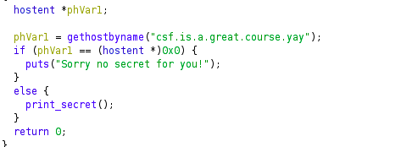
Step02: Add the hostname to kali’s hosts
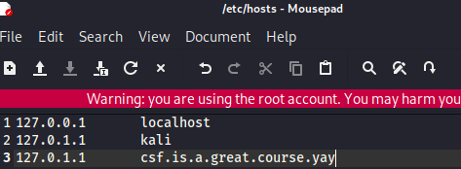
Step03: Run q2

Answer:
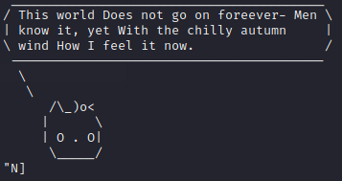

Q03
Step01: Open q3 with write mode
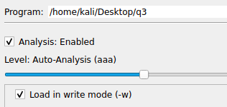
Step02: Change jle 0x7e7 to jmp 0x7e0
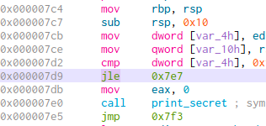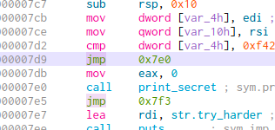
Step03: Run q3

Answer:
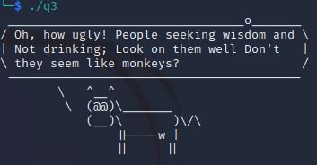

Q04
Step01: Use binwalk to analyze the file, found a Zlib
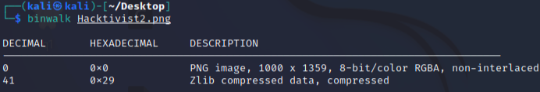
Step02: extract the Zlib
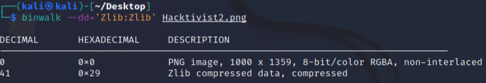
Step03: Browse the bit plane on stegonline, get a hint
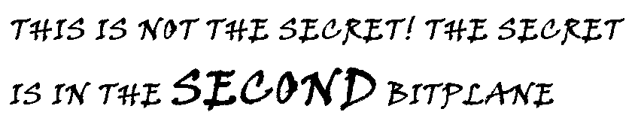
Strp04: Select the second bitplane of this png, get a gzip
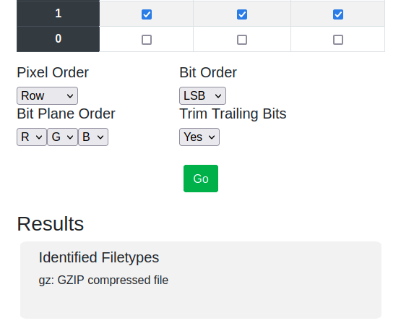
Step05: Extract a PCAPNG from the gzip
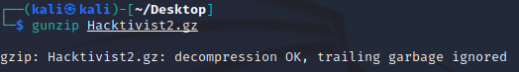
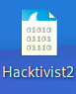
Step06: In Wireshark, export the q4.secret.gz
Sttep07: Again, extract the secret from this gzip
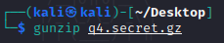
Answer:
